### AI-Statistical Machine Learning Approaches to

### Liver Disease Prediction

**Team ID: PNT2022TMID48272**

**Faculty Mentor Team Leader:** G.lydia

D.**Pradhiba Team Member:** R.priya

**TeamMember:**U.lavanyasri

**TeamMember:**G.nagalakshmi

Project structure

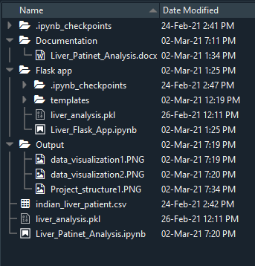

* We have three folders dataset, Flask and Training.
* Dataset has dataset indian_liver_patient.csv.
* A python file called Liver_Flask_App.py for server side scripting.
* We need the model which is saved and the saved model in this content is liver_analysis.pkl.
* Templates folder which contains home.html and upload.html files.
* Training folder has Liver_Patient_Analysis.ipynb where the model is created and saved.
* Static folder which contains css(styling), fontawe some(styling), img(images), js(Java script) folders to enhance the features of the web page.